Accessing Synology NAS drive from Ubuntu

$ sudo apt-get install cifs-utils
Go to Files → Other locations
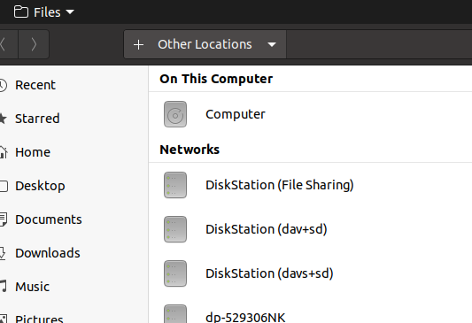

The DiskStation appears; Click on the File Sharing version; Enter credentials; Connect
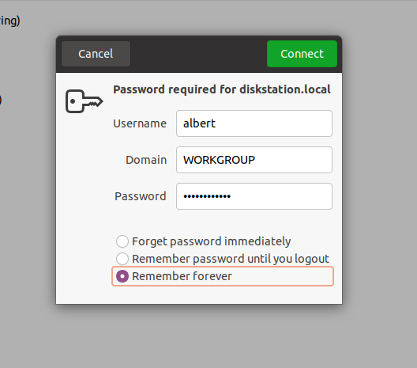

Go to the ubuntu shared folder; Left click and drag to Bookmarks

Other notes from a post. Seem to be optional
sudo mkdir -p /media/NAS/Common_Files
sudo mkdir -p /media/NAS/synology_documents
//192.168.n.nnn/Common_Files /media/NAS/Common_Files cifs username=your_user_name_in_NAS,password=your_password_in_NAS_share,rw,uid=1000,gid=500
//192.168.1.40/documents /media/NAS/ synology_documents cifs username={username},password={password},uid=1000,gid=500
To check that it mounts in terminal sudo mount -a

